Abdrushin
- German Abdruschin
- Abd-ru-shin from ancient times
- civil name Oskar Ernst Bernhardt

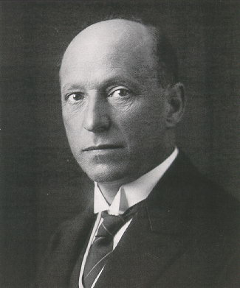Abdrushin

